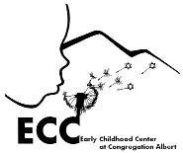

Dear ECC families,

To assist you in providing the best health care for your child(ren), here are a recommended list of medical professionals for you to use as a resource.

All the providers and offices listed here have pediatric specialties.

Pediatrics:
Dr. Joel Berger (After Hours Pediatrics): 298–2505
Dr. Guy Crocetti (After Hours Pediatrics): 298-2505
Melanie Robbins, CNP FNP: 266-3835

Audiology:
Albuquerque Hearing and Balance: 890-0003
Ear Associates: 224-7610
Ophthalmology:
Eye Associates: 888-5757
Family Eye Care of NM: 243-9739

Dental:
David Martinez: 314-0645
Tamera Coffman: 433-3366
Dr. Meckler: 878-0700

